The Star Spangled Banner Chapter is the oldest continuously operating MOAA chapter in Maryland. Founded in 1964, we strongly support MOAA's powerful advocacy with Congress. We are active with the Maryland Council of Chapters in meeting with our federal and state legislators, educating them about the concerns of veterans and retirees. We pursue Maryland State tax free military retirement pay. We support several meaningful philanthropic causes for veterans and local ROTC/JROTC programs all the while enjoying “camaraderie with a purpose.”
New members bring clout to our Chapter, which, in concert with MD Council and National MOAA, acts as “One Powerful Voice”, supporting National Security and ensuring the nation keeps its commitments to all active duty, retired and former servicemembers and their families and survivors. Visit our comprehensive website at www.starspan.org.
We conduct a variety of meetings or field trips at various locations with outstanding guest speakers. We meet at dinners, luncheons, and historic sites at least six times per year. You can participate as much or as little as you desire. Spouses and guests are always welcome! Join the Camaraderie!
For information contact:
LTC Bill Gray, USAR (Ret), Membership Chair
13036 Beaver Dam Rd.,Cockeysville, MD 21030 graybillo@verizon.net or
George Stakias, Colonel, USA (Ret)
Chapter President, 410-707-6947
georgestakias@gmail.com
Legislative Advocacy Philanthropy and “Camaraderie
with a Purpose”

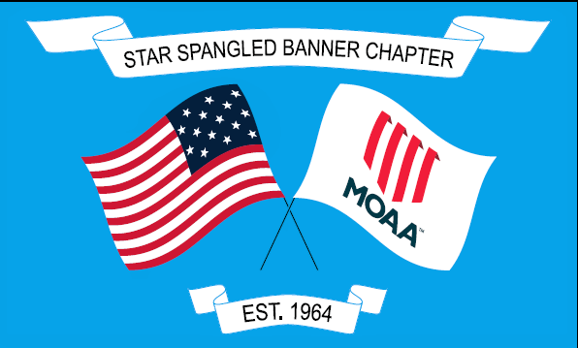
STAR SPANGLED BANNER CHAPTER

Visit us at www.starspan.org
“Never stop serving”

MILITARY OFFICERS ASSOCIATION OF AMERICA
LTC Bill Gray, USAR (Ret)
13036 Beaver Dam Rd.
Cockeysville, MD 21030
(MOAA)

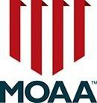

www.moaa.org

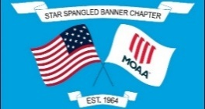

PLEASE JOIN US!
SEND US $30 AND
WE’LL DO THE REST.
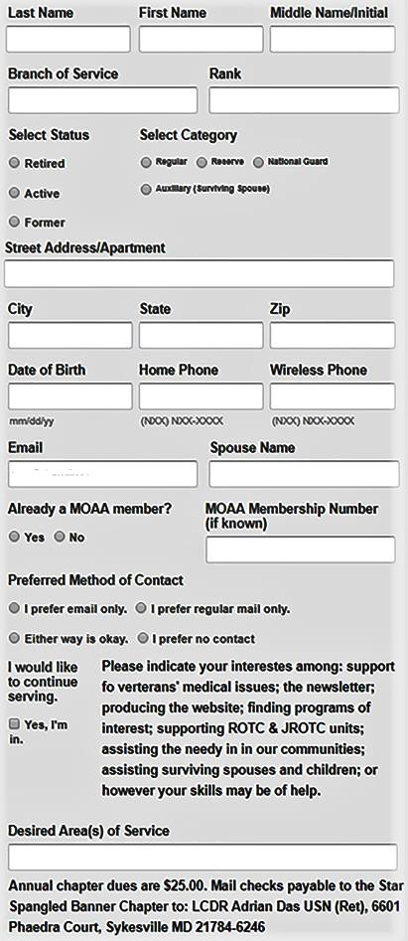
Cut off and mail this application with $30 annual dues check (payable to: Star Spangled Banner
Chapter) to: Treasurer, COL Rita M. Kurek, USAF (Ret), 1231 Engleberth Rd, Essex MD 21221
Life and Premium National Chapter Members DO NOT PAY first-year dues!
CONGRESSIONAL LEGISLATION


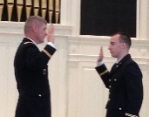
MOAA has worked on a national level to speak on out legislation to benefit all Uniform Services members and retirees and their families. For the 119th Session of Congress set to conclude in January 2026 we are urging members of Congress to pass the Major Richard Star Act that would correct the fact that Disabled Veterans will at last receive their full retirement and their Disability Pay rather than collecting an amount that totals their retirement pay only. In addition, there is support for the Military Spouse Hiring Act that will add spouses to the Work Opportunity Tax Credit. Various efforts have been made so that Uniform Services members will have the ability to carry their children until age 26 like the maximum that civilians have the Affordable Care Act. The latest proposal is the Health Care Fairness Act.

LEGISLATION –STATE, CITY, COUNTY


Our Chapter and the MD Council of Chapters are fighting hard to achieve 100% tax exemption from MD state taxes for all uniformed services retirees. Our chapter has contributed legislative support and economic analysis to pass legislation to achieve MD state tax exemption for all retirees age 55 and older in past years, and we will continue to fight for our goal until it is realized!
See www.starspan.org
We will continue to push for a ban on companies assisting with VA certification from charging for this service, to push for affordable childcare for active uniform services families and expedite licensure and certification for Uniform Service members, their spouses, and retirees.
See www.starspan.org
Together, we can do it!
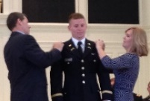
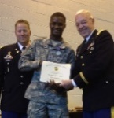
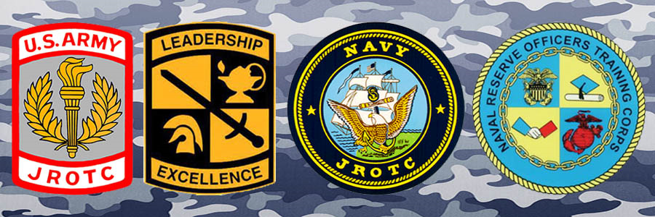
ROTC/JROTC
We support three major university Army ROTC Programs, JHU, Loyola and Morgan State with awards and present the Army Office Guide to new 2nd Lieutenants. Many high schools Junior ROTC units are provided encouragement with leadership awards.


We encourage donations to the MOAA Scholarship Fund and the MOAA Foundation.



Our chapter supports the paws4vets.org assistance dog placement program foundation where veterans, service members and dependents can receive specially trained assistance dogs for critical disabilities. Join our annual special Fundraiser at Columbus Gardens. See our website www.starspan.org or call us for details and reservations. It will warm your heart!


Chapter membership is open to active duty, former, and retired warrant and commissioned officers and their surviving spouses of all seven services living in Baltimore City and the surrounding counties. We have an Annual Banquet in November hosting a distinguished speaker. We often have international affairs experts; government officials and military history authors speak at our various meeting venues. Members and spouses participate each in their own way. Please join us! You will be glad you did!
-- Col George Stakias, USA (Ret) Chapter President

